Ken Overby Jewish Awareness Ministries
How Hezekiah Replaced Fear With Faith
2 Kings 18:1-13, 2 Chron. 28-30, Isaiah 37

Historical context
Hezekiah became king in a politically hostile, anti-God environment yet determined to set things right. Hezekiah gave us a pattern for faith in God in the face of a godless assault on our nation, our faith, and our freedoms.
Assyrian Invasion The Northern Kingdom of Israel had fallen seven years prior in 721 b.c. 2 Kings 18:10-13
Starvation prompted unimaginable behavior, even cannibalism before the conquering of Samaria. 2 Kings 6:24-33
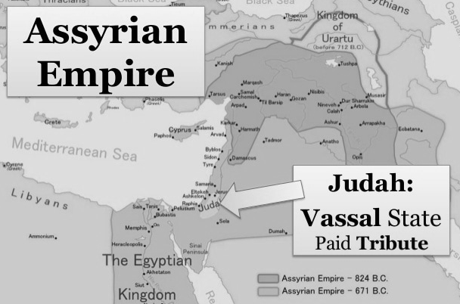
Barbarism Jonah so feared the Assyrians that he ran from God’s call to avoid them. When the city of Nineveh did repent, Jonah was depressed that God had mercy on those monsters. They were the ancient-day “ISIS”. One Assyrian king commissioned an engraving that boasted - “I flayed all the chiefs who had revolted, and I covered the pillar with their skin. Some …I impaled upon the pillar on stakes… and I cut the limbs of the officers, Many I burned with fire. From some I cut off their noses, their ears, their fingers, of many I put out the eyes. I made one pillar of heads, and I bound their heads to tree trunks round the city. Their young men and maidens I burned in the fire.”
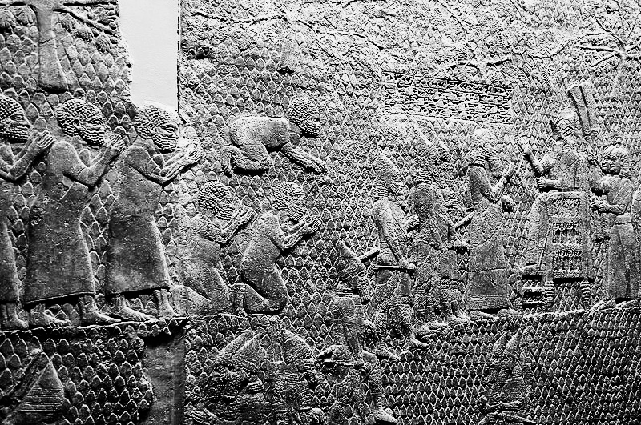
The text of the Sennacherib prism unearthed in 1830 boasts how Sennacherib destroyed 46 of Judah's cities and trapped Hezekiah in Jerusalem "like a caged bird." During the siege of Lachish Hezekiah emptied the Temple treasury of 300 talents of silver and 30 talents of gold to appease him.
Jerusalem
A wall relief from the South-West Palace at Nineveh. The cuneiform inscriptions reads: "Sennacherib, king of the world, king of Assyria sat on a throne and the booty of Lachish (referring to conquered Jews) passed before him."

Refugee Crisis – The Jerusalem population was swollen with Northern Kingdom and Judean refugees. Food shortages were inevitable. “2 Chronicles 30:1-18 explicitly mentions northern Israelites who had been spared by the Assyrians, in particular people of Ephraim, Manasseh, Asher, Issachar and Zebulun; and how members of the latter three returned to worship at the Temple in Jerusalem during the reign of Hezekiah. Thus no “lost tribes.”

Paralyzing Fear - Sennacherib was at the gates!! Far more than just their freedom of speech, religion, and their economy were at stake. Jerusalem led by Hezekiah and Isaiah begged God to save them from torture and death.

Military appeasement by the previous administration – Hezekiah’s father King Ahaz had cut in pieces the vessels dedicated to the service of the Lord to pay tribute and he closed the Temple in Jerusalem.
2 Chronicles 29:3 “in the first year of his reign, in the first month, (Hezekiah) opened the doors of the house of the Lord, and repaired them. 19 Moreover all the vessels, which king Ahaz in his reign did cast away in his transgression, have we and sanctified, and, behold, they are before the altar of the Lord.”

King Hezekiah made a promise that the Assyrians would never rule the people of Jerusalem.
2 Chronicles 32:7 “Be strong and courageous, be not afraid nor dismayed for the king of Assyria, nor for all the multitude that is with him: And the people rested themselves upon the words of Hezekiah king of Judah.” The more threats they heard his citizens began to doubt the kings words as mere boastful rhetoric. Then Rabshakeh, the
B C NN News Anchor for Sennacherib, sent a message to shake them up. 2 Chronicles 32:15-19 Isaiah 36:18 “Beware lest Hezekiah persuade you, saying, The Lord will deliver us.”

Current American Application - We can relate to the fear of those Jews. Just as Israel was under fear, our country is besieged with fear. A virus from China has ravaged the planet and the deaths of 677,000 Americans is attributed to “Covid.” Finally, there are vaccines, although untrusted by many, due to so much conflicting data and a late, recent FDA approval of only one of them. The government is now threatening a second lockdown. Hospitals, schools, and Federal institutions threaten firing employees who refuse the vaccine. The political and media left is blaming all these deaths on one man, former President Trump for political purposes. I praise God, the very first thing Donald Trump did as President, was to cut funds to abortion clinics and ask pastors and spiritual leaders to his office to pray for him and advise him. We have cheered the comittment- “We will never become a Socialist nation!” Now we’re beginning to wonder. Political corruption is obvious. Our greatest threat is not from without but from within. Violent anarchy of rioting has ravaged many of our cities, while “Defund the Police” has become a populist mantra. Crime is surging. Inflation may soon reach double digits.
News sources have become openly politically biased. These are modern Rabshakehs. They vow to ram their godless policies down our throats. We, like the people of Jerusalem, want to rest our hopes on the words of a modern-day Hezekiah. We watched in disbelief when “The city of Los Angeles, through a cease and desist letter, threatened Grace Community Church and Pastor John MacArthur with a daily fine of $1000 or arrest for defying orders about indoor worship services and public singing.” Now Pastor MacArthur has won that suit, just to exercise constitutionally guaranteed freedom of worship. “In Pew Research Center surveys conducted in 2018 and 2019, there were approximately 178 million Christian adults in the U.S. Today there are 23 million more adults in the U.S. than there were in 2009. There are now roughly only 167 million Christian adults in the U.S. (Population increasde by 23 million, Christians decreased by 11 Million) 22 out of 100 Americans say they are “nones” - non-religious, up 8% over the past decade.

Hezekiah believed When the enemy is at the gates and our fears rage, we need something more than political promises and positive thinking slogans. The “people rested themselves upon the words of Hezekiah.” Human confidence is fleeting. Hezekiah didn’t boast on being the greatest country or rally people around a “Make Israel Great Again” slogan. He focused on making faith in God great again. “With him is an arm of flesh; but with us is the Lord our God to help us, and to fight our battles.” 2 Chronicles 32:8
Cab of dung
Hezekiah prayed He took the letter “spread it before the Lord.” (In 133 words He asked God to do the impossible.)
2 Kings 19:1-4, Isaiah 37:14-20 “And it came to pass, when king Hezekiah heard it, that he rent his clothes, and covered himself with sackcloth, and went into the house of the LORD.” 2 Kings 19:19 “save us out of his hand, that all the kingdoms of the earth may know that thou art the LORD God, even thou only.” Isaiah 37:20

God answered “Thus saith the Lord… I have heard.” 2 Kings 19:20
- We must take our fears to God in prayer
People around us are in fear and despair of possibly more difficult times ahead. They need to see an ordinary person like them step forward to follow Jesus in rescuing the perishing. “God has not given us the spirit of fear, but of power of love and a sound mind.” A godless nation in fear needs to see a fearless church. Our response should be. “Wherefore let them that suffer according to the will of God commit the keeping of their souls to him in well doing, as unto a faithful Creator.” 1 Peter 4: 19
- We can be assured He has heard us.
- We can know He has compassion on our weakness 2 Kings 19:26 “small of power, dismayed and confounded”
- Believe that GOD WILL FIGHT OUR BATTLES.
Let God answer the threats of the godless 2 Kings 19:22-28 “Whom hast thou reproached and blasphemed? and against whom hast thou exalted thy voice, and lifted up thine eyes on high? even against the Holy One of Israel. But I know thy abode, and thy going out, and thy coming in, and thy rage against me. Because thy rage against me and thy tumult is come up into mine ears, therefore I will put my hook in thy nose, and my bridle in thy lips, and I will turn thee back by the way by which thou camest.” Isa. 37:28,29
- God is more concerned with our weakness of faith, than our national/political weakness.

We need to repent and humble ourselves from our backsliding and turn to God.
- 2 Chronicles 30:5-11 Hezekiah called a belated Passover “They had not done it of a long time.”
- Some of the people in Ephraim, Manasseh and Zebulun laughed at this antiquated blood religion 30:10
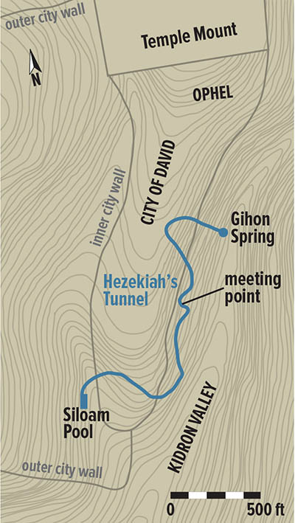
- “nevertheless divers/ various people “humbled themselves and came to Jerusalem…God gave them one heart to obey so they prepared their heart to seek God.” 30:11
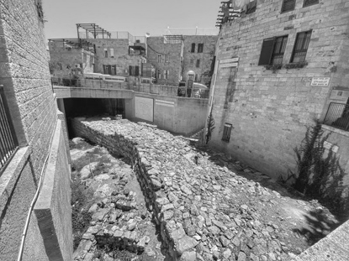
Hezekiah prepared them for the worst.. Workers then dug a 533-meter tunnel to the Spring of Gihon, providing the city with fresh water. The curving tunnel is 583 yards (533 m; about ¹⁄₃ mile) long and by using the 12 inch (30 cm) altitude difference between its two ends, which corresponds to a 0.06 percent gradient, the engineers managed to convey the water from the spring to the pool.
Preparations included, construction of towers, and the erection of a new reinforcing wall.
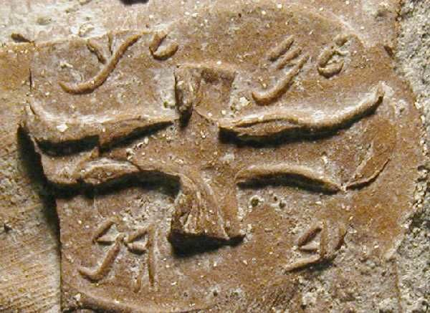
“One of the most significant archaeological discoveries made in recent years (6/2020) just outside the Old City of Jerusalem revealed a 2700-year old structure dating from the 8th century BC. Inside was a treasure trove of clay seal impressions stamped with ancient Hebrew scripts one signifying King Hezekiah. Research indicates the site operated as an administrative center and storage facility during the reign of Hezekiah, King of Judea. From the more than 120 jar handles it is evident that, this site, served as storage of large clay jars, filled with the tax currency of wine and olive oil." Archaeologists digging on Jerusalem's Mount of Olives have discovered jar handles bearing the inscription “belonging to the king,” these seals have been dated to the late eighth century b.c., when King Hezekiah was facing Assyrian invasion. This seems to hint that the jars journeyed from their place of creation before being shipped to the main fortified cities in each region, ready for invasion by Assyria. Several of the handles, were inscribed with the four Hebrew letters Lamed Mem Lamed Kaf (LMLK), meaning (Belonging to the King) or Dedicated for the King’s service.” These seals add evidence to the historical accuracy of the biblical account, showing the preparations made to meet the Assyrian invasion, which ultimately was stopped at Jerusalem by a miracle from God. King Ahaz had discarded the vessels of worship in the Temple. Hezekiah had restored and sanctified “all the vessels… we sanctified and behold! They are before the Lord” 2 Chron. 29:19 God wants to use us as vessels in His service. 2 Timothy 2:19-‬22 “But in a great house there are not only vessels of gold and of silver, but also of wood and of earth; and some to honour, and some to dishonour. If a man therefore purge himself from these, he shall be a vessel unto honour, sanctified, and meet for the master's use, and ‬prepared unto every good work.” ‬‬‬‬‬‬‬

This biblical account of Hezekiah reveals four of God’s purposes for difficult times.

After the Temple was purged in 8 days and the grounds of the Temple in 16 days 2 Chronicles 29:17

- They prayed in confession 29:6
- They were pardoned by God 30:2
- They prioritized God first in their lives 30:22,23,26,27

How did it turn out with the coming invasion?

Isaiah 37: 36 “Then the angel of the Lord went forth, and smote in the camp of the Assyrians a hundred and fourscore and five thousand: and when they arose early in the morning, behold, they were all dead corpses.”
2 Chronicles 32:21,22 “So he returned with shame of face to his own land. Thus the Lord saved Hezekiah and the inhabitants of Jerusalem from the hand of Sennacherib the king of Assyria.”

To turn our fear into faith requires
- We must take our fears to God in prayer
- We can be assured He has heard us.
- We can know He has compassion on our weakness
- Believe that GOD WILL FIGHT OUR BATTLES.

Submit to God’s purpose in difficult times

- Purge us from sin
- Prepare us for service
- Teach us to Pray
- Perform His work as we obey His Word

God uses these time to show His glory

It all started with what Hezekiah determined in 2 Kings 29:10 “Now it is in mine heart to make a covenant with the Lord God of Israel, that his fierce wrath may turn away from us.” Hezekiah commissioned the priests “My sons, be not now negligent: for the Lord hath chosen you to stand before him, to serve him, and that ye should minister unto him.” 2 Kings 29:11

Historical context The thing that had preoccupied the minds of Hezekiah and his Jewish subjects of the Southern Kingdom of Judah for the past 7 years was the impending Assyrian invasion. These are the same Assyrians that Jonah so feared that he ran from God’s call to avoid. When the city of Ninevah did repent, Jonah was totally depressed that God had mercy on those monsters. They made our modern day ISIS seem mild. One Assyrian king commissioned an engraving that boasted - “I built a pillar over his city gate and I flayed all the chiefs who had revolted, and I covered the pillar with their skin. Some …I impaled upon the pillar on stakes… and I cut the limbs of the officers, Many I burned with fire. From some I cut off their noses, their ears, their fingers, of many I put out the eyes. I made one pillar of heads, and I bound their heads to tree trunks round the city. Their young men and maidens I burned in the fire.”

Sennacherib of Assyria had already enslaved and deported the 10 Northern Tribes of Israel. (2 K 18:10-13) He had taken the towns surrounding Jerusalem. The population inside the walls was swollen with Judean refugees. Sennacherib was at the gates!! Far more than just their freedom of speech, religion and their economy, their very lives were at stake. Their FEAR WAS PARALYZING. The residents of Jerusalem with Hezekiah and the Prophet Isaiah begged God to save them.
In our current situation we can relate to the fear of those Jews. Just like Sennacherib had Israel under fear, our country under siege with fear. Political Corruption, A virus from China has ravaged the planet and 677,000 Americans have died. Finally there are vaccines, though untrusted by many due to a Late recent FDA approval of one of them. The government is threatening another lockdown. The political and media left is blaming the deaths on one man the now former, President Trump for political purposes. Our threat is not from without but from within. Violent anarchy to intimidate us has been on display.

Hezekiah became king in a difficult anti-God environment and set things right. His father had cut in pieces the Temple vessels dedicated to the service of the Lord and closed the Temple in Jerusalem.
2 Chron. 29:3 tells us that “in the first year of his reign, in the first month, opened the doors of the house of the Lord, and repaired them. 19 Moreover all the vessels, which king Ahaz in his reign did cast away in his transgression, have we and sanctified, and, behold, they are before the altar of the Lord.” I praise God, the very first thing our president did was to cut funds to abortion clinics, and ask pastors and spiritual leaders to his office to pray for him and advise him.
Hezekiah gave us a pattern for faith in God in the face of a Godless assault on our nation, and religious freedoms
Hezekiah made a promise that the Assyrians would never rule the people of Jerusalem.
2 Chron. 32:7 Be strong and courageous, be not afraid nor dismayed for the king of Assyria, nor for all the multitude that is with him: And the people rested themselves upon the words of Hezekiah king of Judah.” The more threats they heard the more his citizens were beginning to doubt that as just flamboyant political rhetoric. We have cheered at the phrase - “We will never become a Socialist nation.!” Now we’re beginning to wonder.

Then Rabshakeh, the CNN News Anchor for the Assyrian King, sent a message to shake them up. 2 Chron. 32:15-19
Isa. 36:4 And Rabshakeh said unto them, 18 Beware lest Hezekiah persuade you, saying, The Lord will deliver us.

We have been under a constant barrage of FAKE News. Now we are hearing the words from modern Rabshakehs/news anchors. They vow to ram their godless policies down our throats. We like the people of Jerusalem want to rest our hopes on the words of an Hezekiah, but it seems the enemy has the majority. They don’t but are LOUDER.
We all watched in disbelief when “The city of Los Angeles, through a cease and desist letter, threatened Grace Community Church and Pastor John MacArthur with a daily fine of $1000 or arrest for defying orders about indoor worship services and public singing.” Now finally he has won that law suit just to exercise his constitutionally guaranteed freedom of worship.

When the enemy is at the gates and our fears rage, we need something more than political promises and positive thinking slogans. “the people rested themselves upon the words of Hezekiah.” Human confidence is fleeting.

Hezekiah Believed 2 Chron. 32:8 “With him is an arm of flesh; but with us is the Lord our God to help us, and to fight our battles.
Hezekiah Prayed (2 K 19:1-4, Isaiah 37:14-20) He took the letter “spread it before the Lord.” Isa. 37:1 And it came to pass, when king Hezekiah heard it, that he rent his clothes, and covered himself with sackcloth, and went into the house of the Lord. (In 133 words He asked God to do the impossible) 2 K 19:19 “save us out of his hand, that all the kingdoms of the earth may know that thou art the LORD God, even thou only.” (Isa. 37:20)

God Answered
2 K 19:20 “Thus saith the Lord… I have heard.”
- We must take our fears to God
People around us are in fear and despair of possibly more difficult times. They need to see an ordinary person like them step forward to follow Jesus in rescuing the perishing. They don’t need to see us cowering in fear. “God has not given us the spirit of fear, but of power of love and a sound mind.” A nation in fear needs to see a fearless church. Our response 1 Peter 4: 19 “Wherefore let them that suffer according to the will of God commit the keeping of their souls to him in well doing, as unto a faithful Creator.”
- We can be assured He has heard us.
- We can know He has compassion on our weakness 2 K 19:26 “small of power, dismayed and confounded”
- We must believe the promises of the Word of God. HE WILL FIGHT OUR BATTLES.
2 K 19:22 Whom hast thou reproached and blasphemed? and against whom hast thou exalted thy voice, and lifted up thine eyes on high? even against the Holy One of Israel. 27 But I know thy abode, and thy going out, and thy coming in, and thy rage against me. 28 Because thy rage against me and thy tumult is come up into mine ears, therefore I will put my hook in thy nose, and my bridle in thy lips, and I will turn thee back by the way by which thou camest. (Isa. 37:28,29)
God is more concerned with our spiritual weakness than our national/political weakness

In our weakness we need to repent and humble ourselves at the foot of the cross for our backsliding and turn to God.
- 2 Chron. 30:5 Hezekiah called a belated Passover “They had not done it of a long time.”
- 30:10 Some of the people in Ephraim, Manasseh and Zebulun laughed at this antiquated blood religion
- 30:11 “ nevertheless divers/ various people “humbled themselves and came to Jerusalem…God gave them one heart to obey 30:19 so they prepared their heart to seek God.

Ahaz had discarded the vessels of worship in the Temple. That’s what Satan wants to do with us.
Hezekiah had restored them. Our flesh wants to carelessly defile them with self and sin
God wants to use us a vessels in His service
The vessels must be sanctified. 2 Chron. 29:19 “all the vessels… we sanctified and behold! They are before the Lord”

One of the most significant archaeological discoveries made in recent years just outside the Old City of Jerusalem (6/2020) revealed a 2700-year old structure dating from the 8th century BC. Inside was a treasure trove of clay seal impressions stamped with ancient Hebrew scripts one signifying King Hezekiah. Research indicates the site operated as an administrative center and storage facility during the reign of Hezekiah, King of Judea. From the more than 120 jar handles it is evident that, this site, served as storage of large clay jars, filled with the tax currency of wine and olive oil." Several of the handles, were inscribed with the 4 Hebrew letters Lamed Mem Lamed Kaf (LMLK), meaning (Belonging to the King) or Dedicated for the King’s service . https://www.israelhayom.com/wp-content/uploads/2020/07/5698.jpg

As soon as I read about this discovery I penned this title - Preparing our Vessels for the King’s Service.
2 Timothy 2:19-‬22 “But in a great house there are not only vessels of gold and of silver, but also of wood and of earth; and some to honour, and some to dishonour. If a man therefore purge himself from these, he shall be a vessel unto honour, sanctified, and meet for the master's use, and ‬prepared unto every good work.” ‬‬‬‬‬‬‬

As I studied the passages about King Hezekiah, I saw four purposes for difficult times. God uses them to
Purge us. Prepare us. Get us to Pray. To Perform His work

(29:17) After the Temple was purged in 8 days and the grounds of the Temple in 16 days
- prayed in confession (29:6)
- pardoned by God (30:20)
- prioritized God first in their lives (30:22,23,26,27)

Pottery jar handles, inscribed with Lamed Mem Lamed Kaf (LMLK), meaning for the King’s service
Archaeologists digging on Jerusalem's Mount of Olives have discovered a nearly 3,000-year-old jar handle bearing the inscription “belonging to the king,” these seals have been dated to the late eighth century b.c., around the time King Hezekiah was facing Assyrian invasion. This seems to hint that the jars journeyed from their place of creation in the Shephelah (hill country of Samaria) to one of the four districts to gather supplies, before being shipped to the main fortified cities in each region, ready for invasion by Assyria. The LMLK seals add valuable validity to the biblical account, showing the preparations King Hezekiah made to meet the Assyrian invasion, which ultimately was stopped at Jerusalem by a miracle from God. They are an incredible part of the wealth of evidence for the veracity of this biblical story.

- Hezekiah had had the people busy preparing.
King Hezekiah, had marshalled the citizens of Judea and Jerusalem to f fortify and expand the city walls a half mile south to include the Pool of Siloam, Jerusalem’s main water source. In less than 4 years his engineers built a winding tunnel 1/3 of a mile long, inside the mountain to enclose the gushing Gihon spring that feeds it, so they could survive the coming siege ensuring that the enemy could not access water or cut off their source. They were motivated. Judgment was coming. Prepare or die. They had done all they could to prepare against a human enemy.
- They had built and strengthened their defensive walls.
- They had dug a tunnel and a shaft to provide access to water.

- “In Pew Research Center surveys conducted in 2018 and 2019, there were approximately 178 million Christian adults in the U.S. in 2009. Today, there are roughly 23 million more adults in the U.S. than there were in 2009. There are now roughly 167 million Christian adults in the U.S. (Population increase by 23 million, Christians decreased by 11 Million) The number of religiously unaffiliated adults in the U.S. grew by almost 30 million over this period. 22/100 Americans say they are “nones” - non-religious, up 8% over the past decade

Yesterday a 35 year old young man sent me a facebook post of a “receipt for salvation” showing paid in full. He wrote: I am proud to be saved. Thank you again Pastor Ken for teaching me the gospel and introducing me to Christ when I was 13. We put on a Drama called The judgment Seat. He went on to graduate from a Christian College and is active in church and being a witness. THAT’S HOW WE SAVE THIS COUNTRY. If we’ll be about His business He’ll fight our battles.

- May He say of our purged, prepared vessels, Behold we are before the altar of the Lord. Humble our selves and weep at the altar calling on God to save our lost relatives and friends. “He that goeth forth and weepeth bearing precious seed…” We need to be filled with the Spirit and carry forth the water of Life to the lost

- It all started with what Hezekiah determined in 29:10 Now it is in mine heart to make a covenant with the Lord God of Israel, that his fierce wrath may turn away from us. Hezekiah commissioned the Priests 11 My sons, be not now negligent: for the Lord hath chosen you to stand before him, to serve him, and that ye should minister unto him.” Romans 12:1,2

How did it turn out with the coming invasion?

Isa. 37: 36 Then the angel of the Lord went forth, and smote in the camp of the Assyrians a hundred and fourscore and five thousand: and when they arose early in the morning, behold, they were all dead corpses. (Woke up dead)
2 Chron 32:21 So he returned with shame of face to his own land. 22 Thus the Lord saved Hezekiah and the inhabitants of Jerusalem from the hand of Sennacherib the king of Assyria.

Calvary Baptist Church, Bedford VA 8/9/20, 11 AM Pastor Jonathan Hester
Liberty Baptist Church, 9-26-27 11 AM Pastor Gary Styers
Bible Baptist Church Ft. Mill SC 11 am 11-15-20
JAMBS 9-24-21

Pottery jar handles, inscribed with Lamed Mem Lamed Kaf (LMLK), meaning (Belonging to the King) or Dedicated for the King’s service

- Hezekiah had had the people busy preparing.
King Hezekiah, had marshalled the citizens of Judea and Jerusalem to frantically fortify and expand the city walls a half mile south to include the Pool of Siloam, Jerusalem’s main water source. In less than 4 years his engineers built a winding tunnel 1/3 of a mile long, inside the mountain to enclose the gushing Gihon spring that feeds it, so they could survive the coming siege ensuring that the enemy could not access water or cut off their source. They were motivated. Judgment was coming. Prepare or die.

- They had done all they could to prepare against a human enemy.
- They had built and strengthened their defensive walls.
- They had dug a tunnel and a shaft to provide access to water.
(However Archaeologists have been unable to find any stockpiles of toilet paper.)

https://www.pewforum.org/2019/10/17/in-u-s-decline-of-christianity-continues-at-rapid-pace/
“In Pew Research Center telephone surveys conducted in 2018 and 2019, 65% of American adults describe themselves as Christians when asked about their religion, down 12 percentage points over the past decade. 43% of U.S. adults identify with Protestantism, down from 51% in 2009. Meanwhile, all subsets of the religiously unaffiliated population – a group also known as religious “nones” – have seen their numbers swell. 17% of Americans now describe their religion as “nothing in particular,” up from 12% in 2009. (Over the same period, the GSS General Social Survey found that religious “nones” grew from 14% of the U.S. adult population to 22%.)
Growth is most pronounced among young adults. More than eight-in-ten members of the Silent Generation (those born between 1928 and 1945) describe themselves as Christians (84%), as do three-quarters of Baby Boomers (76%). In stark contrast, only half of Millennials (49%) describe themselves as Christians; four-in-ten are religious “nones,” The nation’s overall rate of religious attendance is declining not because Christians are attending church less often, but rather because there are now fewer Christians as a share of the population. there were approximately 178 million Christian adults in the U.S. in 2009. Today, there are roughly 23 million more adults in the U.S. than there were in 2009. There are now roughly 167 million Christian adults in the U.S. (Population increase by 23 million, Christians decreased by 11 Million) The number of religiously unaffiliated adults in the U.S. grew by almost 30 million over this period. The decline in regular churchgoing is attributable mainly to the shrinking share of Americans who say they attend religious services at least once a week, which was 37% in 2009 and now stands at 31%. The share of U.S. adults who are white born-again or evangelical Protestants now stands at 16%, down from 19% a decade ago. Over the last decade, the share of Americans who say they attend religious services at least once or twice a month dropped by 7 percentage points.

2 Chronicles 30:1 And Hezekiah sent to all Israel and Judah, and wrote letters also to Ephraim and Manasseh, that they should come to the house of the Lord at Jerusalem, to keep the passover unto the Lord God of Israel.
5 So they established a decree to make proclamation throughout all Israel, from Beer–sheba even to Dan, that they should come to keep the passover unto the Lord God of Israel at Jerusalem: for they had not done it of a long time in such sort as it was written.
7And be not ye like your fathers, and like your brethren, which trespassed against the Lord God of their fathers, who therefore gave them up to desolation, as ye see.

8Now be ye not stiffnecked, as your fathers were, but yield yourselves unto the Lord, and enter into his sanctuary, which he hath sanctified for ever: and serve the Lord your God, that the fierceness of his wrath may turn away from you.
9For if ye turn again unto the Lord, your brethren and your children shall find compassion before them that lead them captive, so that they shall come again into this land: for the Lord your God is gracious and merciful, and will not turn away his face from you, if ye return unto him.

Preparing your life to be a vessel for the King’s use requires…
- Purging – sanctified Let every one that nameth the name of Christ depart from iniquity.
- Follow – Not the worldly but the Godly
- Faith – Call on God out of a pure heart
- Faithful service till death “Semper Fi”
- First you must fall on the altar of Romans 12:1-3

10 So the posts passed from city to city through the country of Ephraim and Manasseh even unto Zebulun: but they laughed them to scorn, and mocked them.
11Nevertheless divers of Asher and Manasseh and of Zebulun humbled themselves, and came to Jerusalem.
12Also in Judah the hand of God was to give them one heart to do the commandment of the king and of the princes, by the word of the Lord.
13And there assembled at Jerusalem much people to keep the feast of unleavened bread in the second month, a very great congregation.
14And they arose and took away the altars that were in Jerusalem, and all the altars for incense took they away, and cast them into the brook Kidron.
5Then they killed the passover on the fourteenth day of the second month: and the priests and the Levites were ashamed, and sanctified themselves, and brought in the burnt offerings into the house of the Lord.
16And they stood in their place after their manner, according to the law of Moses the man of God: the priests sprinkled the blood, which they received of the hand of the Levites.
17For there were many in the congregation that were not sanctified: therefore the Levites had the charge of the killing of the passovers for every one that was not clean, to sanctify them unto the Lord.

Maybe you are one of those damaged, cast away vessels who used to serve the Lord, We all know people who have been cast away by their sin, love of the world or mistreatment by other Chrisitans.
Hezekiah’s servants of the Temple went out and found them, and restored them. “Ye who are spiritual restore them in the spirit of meekness.” Galatians

18For a multitude of the people, even many of Ephraim, and Manasseh, Issachar, and Zebulun, had not cleansed themselves, yet did they eat the passover otherwise than it was written. But Hezekiah prayed for them, saying, The good Lord pardon every one
19That prepareth his heart to seek God, the Lord God of his fathers, though he be not cleansed according to the purification of the sanctuary.
20And the Lord hearkened to Hezekiah, and healed the people.

21And the children of Israel that were present at Jerusalem kept the feast of unleavened bread seven days with great gladness: and the Levites and the priests praised the Lord day by day, singing with loud instruments unto the Lord.
22And Hezekiah spake comfortably unto all the Levites that taught the good knowledge of the Lord: and they did eat throughout the feast seven days, offering peace offerings, and making confession to the Lord God of their fathers.
23And the whole assembly took counsel to keep other seven days: and they kept other seven days with gladness. (unleavened bread)
26So there was great joy in Jerusalem: for since the time of Solomon the son of David king of Israel there was not the like in Jerusalem.
27Then the priests the Levites arose and blessed the people: and their voice was heard, and their prayer came up to his holy dwelling place, even unto heaven.

Psalm 51:9 “Hide thy face from my sins, and blot out all mine iniquities.
10 Create in me a clean heart, O God; and renew a right spirit within me.
11 Cast me not away from thy presence; and take not thy holy spirit from me.
12 Restore unto me the joy of thy salvation; and uphold me with thy free spirit.
13 Then will I teach transgressors thy ways; and sinners shall be converted unto thee.
“Behold, God is my salvation; I will trust, and not be afraid: for the Lord Jehovah is my strength and my song; he also is become my salvation. Therefore with joy shall ye draw water out of the wells of salvation.” Isaiah 12:2-‬3 https://bible.com/bible/1/isa.12.2-3.KJV‬‬‬‬‬‬‬‬‬

In Acts 1:14,15; 2:1-42 There were 120 clean vessels, filled with the Holy Spirit like oil lamps topped with frames as of fire. They became lamps of the Gospel of the death, burial and resurrection of Jesus. 3000 were saved.

The complex appears to have been abandoned after the Babylonian destruction of Jerusalem in 587 BC
Iron Age Judahite Administrative Complex Unearthed in Jerusalem
￼An aerial photo of the 2700-year-old administrative complex unearthed in the Arnona neighborhood in Jerusalem Photo: Yaniv Berman / Israel Antiquities Autho two-winged LMLK (‘Belonging to the King’) jar handle discovered during the Arnona excavations. Photo: Yaniv Berman / Israel Antiquities Authority
An exceptional 2700-year old structure was recently unearthed between Talpiot and Ramat Rachel in the Arnona neighborhood, outside of the Old City of Jerusalem. Evidence suggests it operated as an administrative center and storage facility during the reigns of Hezekiah and Manasseh in the 8th-7th centuries BC. Over 120 jar handles stamped with ancient Hebrew scripts were uncovered, including numerous handles inscribed with LMLK (“Belonging to the King”). The site’s location and the large number of seal impressions suggests that some of Judah’s administration occurred outside of the City of David during this time period. In addition, a collection of clay idols and figurines depicting women and animals was also found at the site, likely indicating idolatry, a practice that, according to Scripture, was prevalent in Judah during the Iron Age. The complex appears to have been abandoned after the Babylonian destruction of Jerusalem in 587 BC, but was resettled in the Persian-era, after the exiles returned, and administrative activity resumed
From Note: https://goo.gl/ScG4Hc

Additional material
2 Timothy 2:19-‬22 “But in a great house there are not only vessels of gold and of silver, but also of wood and of earth; and some to honour, and some to dishonour. If a man therefore purge himself from these, he shall be a vessel unto honour, sanctified, and meet for the master's use, and ‬prepared unto every good work.
Application – ‬‬‬‬‬‬‬
Preparing your life to be a vessel for the King’s use requires…
- Purging – sanctified Let every one that nameth the name of Christ depart from iniquity.
- Follow – Not the worldly but the Godly
- Faith – Call on God out of a pure heart
- Faithful service till death “Semper Fi”
- First you must fall on the altar of Romans 12:1-3

The miners with no GPS coordinates dug two serpentine tunnels from opposite sides of the mountain and met in the middle “axe against axe” according to the inscription left on the wall. I’ve walked through a portion of this tunnel on one of our annual Jewish Awareness’ trips to Israel. How did they perform the impossible?

People around us are in fear and despair of possibly more difficult times. They need to see an ordinary person like them step forward to follow Jesus in rescuing the perishing. They don’t need to see us cowering in fear. “God has not given us the spirit of fear, but of power of love and a sound mind.” A nation in fear needs to see a fearless church. Our response 1 Peter 4: 19 “Wherefore let them that suffer according to the will of God commit the keeping of their souls to him in well doing, as unto a faithful Creator.”
Hezekiah had a heart to serve God inspite of the impending threat. We need to pray Habakkuk 3:2 “O Lord, I have heard thy speech, and was afraid: O Lord, revive thy work in the midst of the years…in wrath remember mercy.”

The residents of Jerusalem were facing an even worse fate than losing an election. Their worst enemy had already defeated and enslaved the 10 northern tribes 4 years ago. Imagine if the Russians had already invaded and taken the Northeast, Mid-west and China had invaded and taken the West Coast and only North Carolina, South Carolina, Georgia and Florida were left and they were threatening to take us any day now. Many would die in our defense and the fate of our wives and children would be unimaginable.

President Trump learned they were under threat of the IRS because of the Johnson amendment which was a provision of the U.S. tax code that prohibits religious organizations and many nonprofits from opposing or promoting political candidates. President Trump issued this executive order, - not yet voted into law -“ that says the Treasury Department should not treat speech “about moral or political issues from a religious perspective” as a sign of support for or opposition to a candidate.
The residents of Jerusalem were facing an even worse fate than losing an election. Their worst enemy had already defeated and enslaved the 10 northern tribes 4 years ago. Imagine if the Russians had already invaded and taken the Northeast, Mid-west and China had invaded and taken the West Coast and only North Carolina, South Carolina, Georgia and Florida were left and they were threatening to take us any day now. Many would die in our defense and the fate of our wives and children would be unimaginable.
(3) opened the doors of the house of the Lord and repaired them. We were fixer uppers when God found us. Quit criticizing your church and expecting it to be a palace of perfection. How are you repairing the Church to build it up and fill it up with sinners

- (19) prepared all the vessels which were cast away in transgression –Jesus first message in His Synagogue in Nazareth - Luke 4:18 “The Spirit of the Lord is upon me, because he hath anointed me to preach the gospel to the poor; he hath sent me to heal the brokenhearted, to preach deliverance to the captives, and recovering of sight to the blind, to set at liberty them that are bruised”
- sanctified the vessels. Now it’s going to take supernatural power of the HOLY Spirit through us. 29:17 says they got serious and in 8 days cleaned the place up. That is the definition of REVIVAL.
Do I believe Judgment is coming on America? God’s judgment doesn’t begin with fire and brimstone. What does judgment look like? Proverbs says, “The backslider will be filled with his own ways.” and “The way of the transgressor is hard.” God lets us begin to suffer the consequences of our choices first. Seems it has already started on America?
Peter wrote, “the time is come that judgment must begin at the house of God.”
Wait, judgment on the church, and not on the wicked? But why would God judge the ones trying to do right, His own church? Habakkuk asked the same thing and was shocked to learn, that is exactly what God does. But why would God allow the wicked to persecute His own children?

In 1 Peter 4:17-19 Peter reminded the Jewish believers who were already under Roman persecution “ For the time is come that judgment must begin at the house of God: and if it first begin at us, what shall the end be of them that obey not the gospel of God?” Where did Peter say that God’s Judgment begins?... at the house of God. When there begins to be official government sanctioned persecution of Houses of Worship, God is allowing godless pagans to attack His church and people to purge us. But this persecution always triggers God’s wrath on the persecutors of His kids. Peter asked, “and if it first begin at us, what shall the end be of them that obey not the gospel of God?”
God first judged Judea by giving the citizens of Jerusalem a wicked king Ahaz, who cut in pieces the silver and gold vessels of the Temple, then closed the Temple doors. (2 Chron.28:24) He stopped the free exercise of worshiping God.
We know our nation is increasing in wickedness and rebellion against God…
When a society gets so wickedly steeped in the worship of Idolatry/material things and immorality like Hezekiah’s day when his own father sacrificed live infants in the fires of Molech, then it openly “provokes God to wrath.” Has America been provoking God? - 1963 Prayer & Bible removed from schools. 1973 - Abortion legalized. 2015 - Homosexual marriage legalized. 2016 The Democrat party removed any mention of God from their political platform.

For 50 years we have done just like the Kingdom of Judah. Hezekiah’s father King Ahaz… in 2 Chronicles 28:4 “provoked to anger the Lord God of his fathers.” Notice how Ahaz 28:25 “burn incense unto other gods” These very words were Archaeologically verified by this recent discovery which included a collection of idolatrous and immoral ritualistic clay figurines depicting both women and animals. This was right across the street from the Holy Temple in a government building that stored holy oil for the Temple. The government workers of God’s own nation committing idolatry right next to the Temple walls! Approved by the King Ahaz himself! We may very well have such a “king” in 2 months with a modern day Jezebel beside him. But then God raises a Hezekiah and God’s people are encouraged to believe God. God often chooses rulers even pastors from godless backgrounds because of His mercy and grace! He raises up kings and puts down kings. We had an Ahaz 8 years and have had a Hezekiah for 4 who is restoring a blessing to Israel & US. Made God Almighty give him 4 more! God doesn’t need a blue blood to straighten out a royal mess. He can draw a straight line with a crooked stick.

What is amazing is that we question that we His Children have been provoking His chastisement. Have we made the accumulation of material things, comfort and convenience, sports, leisure and entertainment a top priority? Have we allowed any of those to take us away from the Lord and His church? When my Daddy got saved in 1963, Church attendance became the reason we missed everything else. Family reunions-we got there late. Little League – I was pulled from the game in time to get to Prayer meeting. Today, everything else is a reason to miss church. Church attendance has steadily decreased for the last 40 years.

“In Pew Research Center surveys conducted in 2018 and 2019,
https://www.pewforum.org/2019/10/17/in-u-s-decline-of-christianity-continues-at-rapid-pace/
- 65/100 Americans self-describe as Christian, down 12% over the past decade
- Only 16 /100 Americans describe themselves as born again, down 3% over the past decade
- Only 31/100 Americans attend Church weekly, down 6% over the past decade
- 22/100 Americans say they are “nones” - non-religious, up 8% over the past decade
- (Population increase by 23 million, Total Christians decreased by 11 Million)
there were approximately 178 million Christian adults in the U.S. in 2009. Today, there are roughly 23 million more adults in the U.S. than there were in 2009. There are now roughly 167 million Christian adults in the U.S. (Population increase by 23 million, Christians decreased by 11 Million) The number of religiously unaffiliated adults in the U.S. grew by almost 30 million over this period.

https://en.wikipedia.org/wiki/Kingdom_of_Israel_(Samaria)#cite_note-29
https://en.wikipedia.org/wiki/Siloam_tunnel
https://www.israelhayom.com/wp-content/uploads/2020/07/5698.jpg
https://watchjerusalem.co.il/377-to-the-king-seals-point-to-hezekiah

